**How I built this dashboard**

Get data > text/csv >navigate to the file HR Analytics Data.csv on your laptop > transform data and load it into power query.

1. Go to home > split columns > By Delimiter. In the split column by the delimiter window > select or enter delimiter > Tab, split at > each occurrence of delimiter > advanced options > columns > ok.
2. Now we have the headers as column 1.1, column 1.2 and so on. We want the header to be the first row that has been entered. To do this, go back to Home > Click on use first row as header. Click close and apply. This will load the dataset in the Data section.
3. Visualization field > format your report page > Canvas background > 1st colour > transparency 0%.
4. Insert > shapes > rounded rectangle. In format shape > shape > fill > colour > white, transparency > 29 %, border off, shadow on.
5. Now copy paste this shape. In format shape > shape > rounded corners > 7. Now copy paste this, so that we have a total of 4 such cards. Now copy and paste the shapes as necessary to make a total of 11 shapes on the canvas. (Refer to file named 1 in screenshot folder.)

1. Now to insert text: insert > text box > type HR dashboard, select this text, font style seorge bold, size 24, centre aligned, drag and resize to fit in the shape that was created. Again insert > text box > type full insights > font calibiri > size 18 resize. In the format your style, in effects turn background off for both these text boxes. This will turn out as shown: (Refer to file named 2 in screenshot folder.)

1. Insert > shape > circle > adjust the size. In format shape > style > fill colour > select colour, turn border off.

1. In home, click on enter data, In name write All measures. This will create a field called All Measures in the Data field. Now we will create Our first DAX function. Inside All measures, click on column 1, and navigate to new measure.

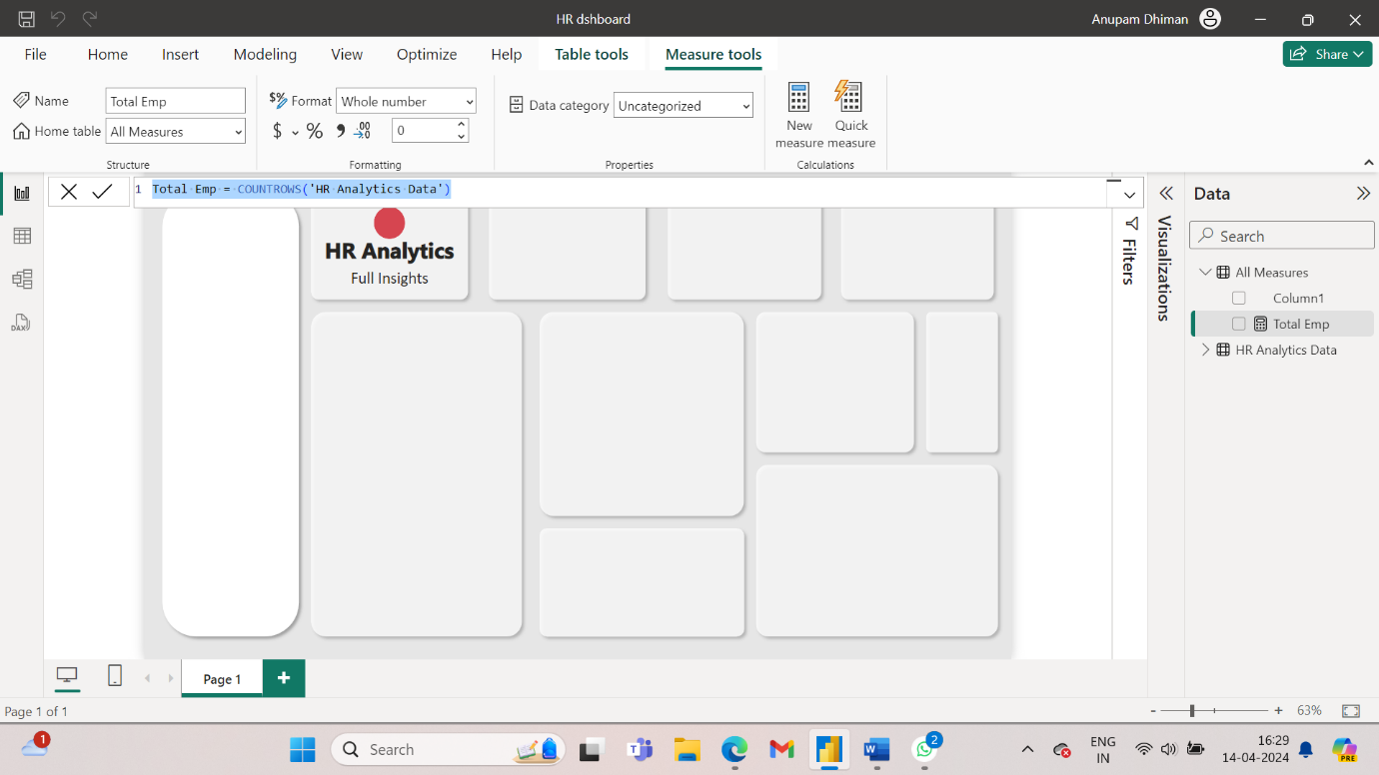

1. Now we create our next DAX functions

Male = calculate([Total emp],’HR Analytics Data’[Gender]=”Male”)

Female = calculate([Total emp],’HR Analytics Data’[Gender]=”Female”)

% male = Divide([Male], [Total Emp], 0)

% female = Divide([Female], [Total Emp], 0)

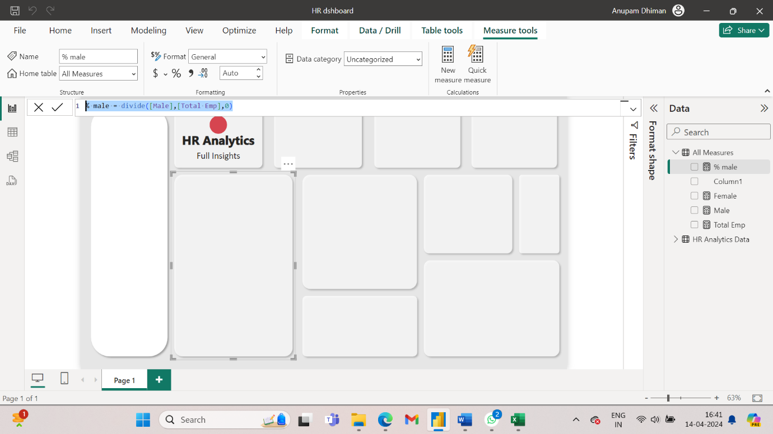

1. Now from the Data field, select Total Emp. Then select card as the visualisation and then format it to get the result as shown in the image:

1. Using male, % male measure fill in card 3 insert the image by navigating to the image stored in local. Similarly fill in card 4 with the measure female and % female.

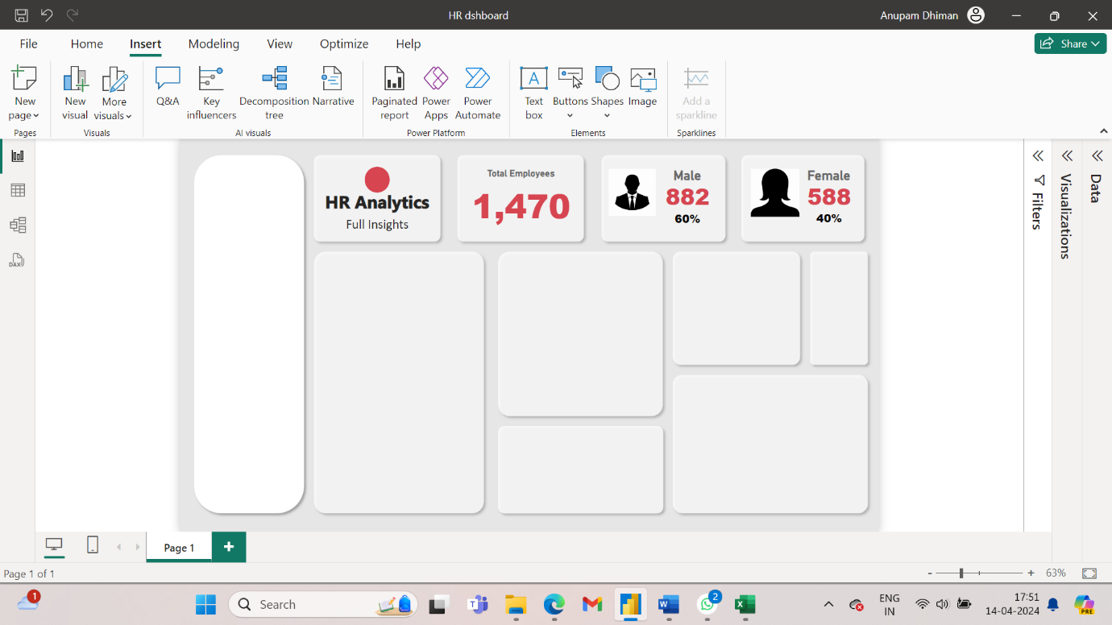

1. Go to transform data and navigate to the column YearsSinceLastPromoted. Now let’s say that the HR manager says that whoever has not been promoted for last 10 years or more is to be promoted. So, let’s first transform the data. Go to transform column > add column > conditional column. Follow the commands on screen and click ok. This will create a new column in the csv file Promotion Status.

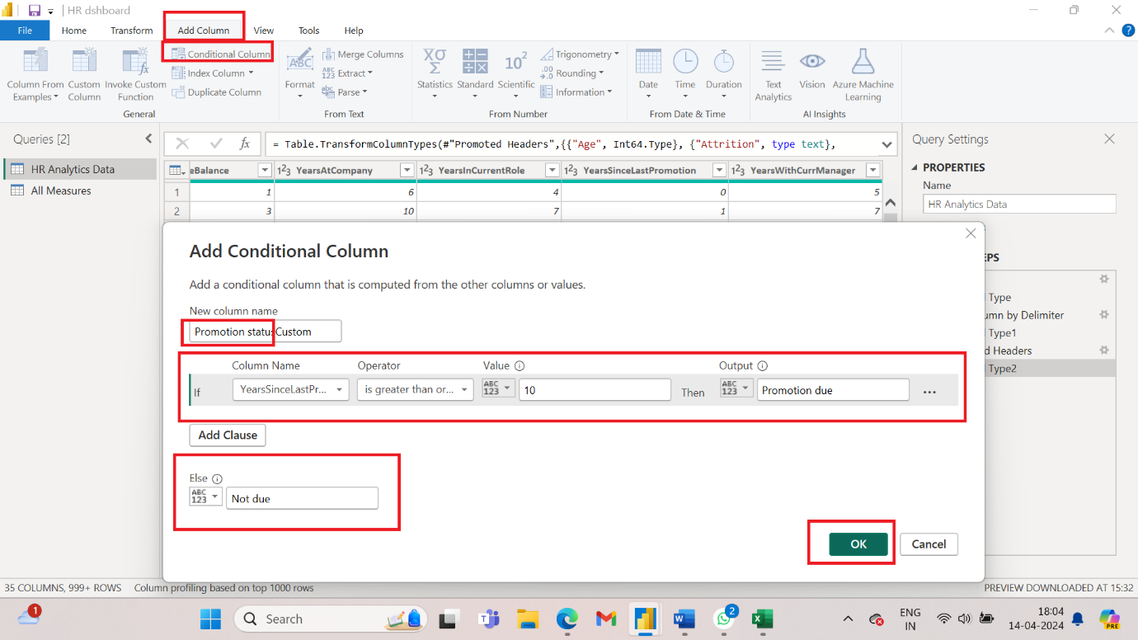

1. Now create two new measures using DAX function:

Due for promotion = CALCULATE([Total Emp],'HR Analytics Data'[Promotion status]="Due for promotion")

Not due for promotion = CALCULATE([Total Emp],'HR Analytics Data'[Promotion status]="Not due ")

% due for promotion = Divide([Due for promotion],[Total Emp],0)

% not due for promotion = Divide([Not Due for promotion],[Total Emp],0)

1. Now we will create another column in our file. Select column YearsAtCompany Home > Transform data > Add column > column from examples > From selection. In the new column, add column Header Service year type 6 years. This will populate everything in the column. Click OK.

1. Next change Job Level column.

1. Go to Home, Close and apply.
2. Make a bar chart of service year and number of employees. In visualisation > tooltips, add male, female, due for promotion, not due for promotion. This way when you select a particular bar in service year, it will show the demographics also.

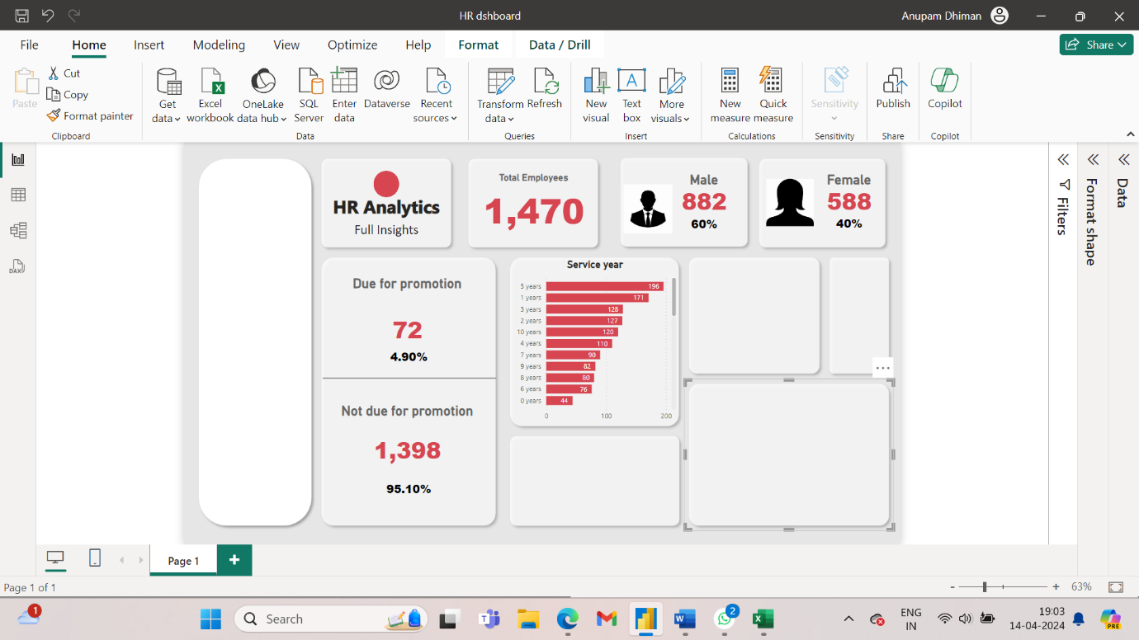

1. Make a stacked bar chart of job level and total employees. Use format visual to make it consistent with the rest of the chart. The colour used is #FF9710.

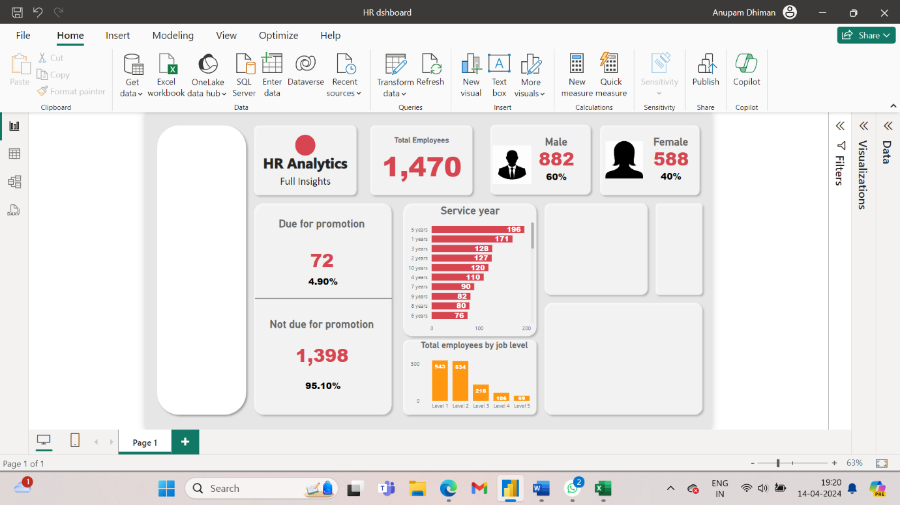

1. Let’s say the company wants to lay-off employees who have spent 18 or more years in the company. So use conditional formatting for this purpose.

1. Create a new measure:

On service = CALCULATE([Total Emp],'HR Analytics Data'[Retrenchment Status] = "On service")

Retrenched= CALCULATE([Total Emp],'HR Analytics Data'[Retrenchment Status] = "Retrenched")

% on service = divide([On service],[Total Emp],0)

% Retrenchede = divide([Retrenched],[Total Emp],0)

Create two charts on service and retrenched along with the value and the percentage as shown:

To account for the dashboard not show blank, modify the power query as On service = if(ISBLANK( CALCULATE([Total Emp],'HR Analytics Data'[Retrenchment Status] = "On service")),0,CALCULATE([Total Emp],'HR Analytics Data'[Retrenchment Status] = "On service"))

Retrenched = if (ISBLANK(CALCULATE([Total Emp],'HR Analytics Data'[Retrenchment Status] = "Retrenched")),0,CALCULATE([Total Emp],'HR Analytics Data'[Retrenchment Status] = "Retrenched"))

Similarly modify due for promotion as

Due for promotion = if(ISBLANK(CALCULATE([Total Emp],'HR Analytics Data'[Promotion status]="Due for promotion")),0,CALCULATE([Total Emp],'HR Analytics Data'[Promotion status]="Due for promotion"))

1. We need to find out the distance from home to work for the next chart.

Change the data type of all columns that have been created to text.

1. Create a donut chart of total employees by distance status. After formatting, the dashboard will look like this:

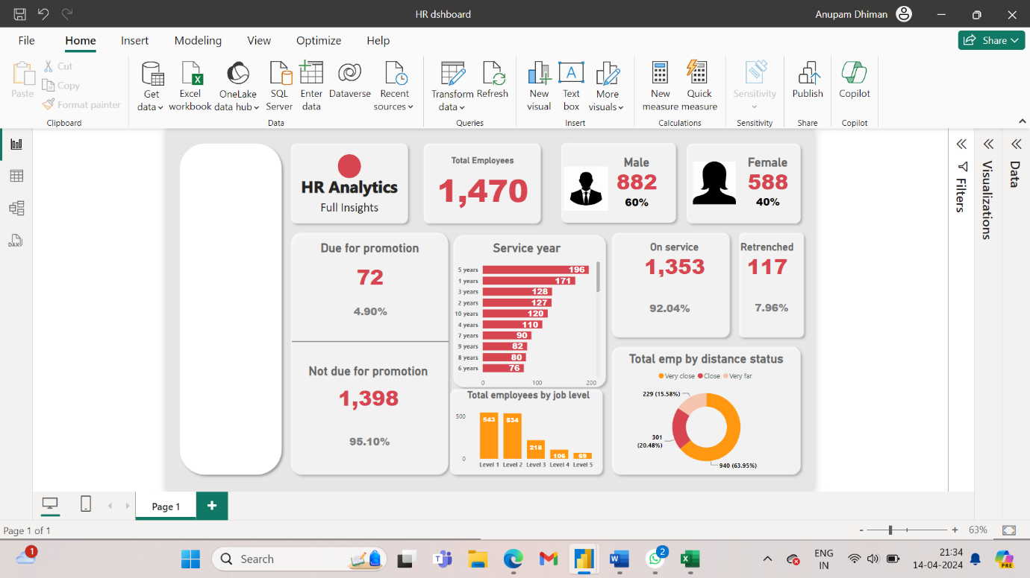

1. Let’s say the company ought to pay severance benefit to the people who are due for promotion and need to be retrenched due to company policy. Our job is to extract those employees before they are retrenched. Get data > text/csv > navigate to HR employees data csv file > open > transform data. Go back to HR Analytics Data in Queries > In the ribbon click on merge queries.

1. Duplicate the home page and rename the duplicate as Action. Create a table with Employee names and due for promotion. Filter these to the employees who are due for promotion where value is greater than or equal to 1.



1. Now to create a bar chart of the employees who are due for promotion and will be retrenched by department, Select the columns will be retrenched, due for promotion, department from the data field.

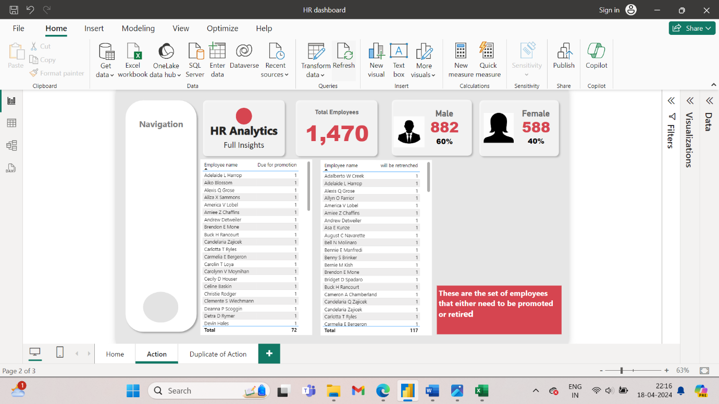Click on 3 dots at the right corner of both tables and download excel file. Now copy the contents of both the excel files into one file and then in the column F of the excel file the formula **=IF(AND(B2=1, D2=1), A2, "")** This formula checks if both "Due for promotion" (column B) and "Will be retrenched" (column D) have a value of "1" in the same row. If true, it returns the name of the employee from column A; otherwise, it returns an empty string. You can filter or sort this column to remove the empty cells and get a clean list of names.

1. Create new measure, severance = Countrows(“Sheet 1”). Now make a card that displays that there are 54 people who must be given a severance package.
2. Create a bar chart by selecting the columns department, will be retrenched and due for promotion. Perform the necessary formatting.

1. Now to create a card for job satisfaction we must create the columns. If we try to visualize the already existing Job satisfaction column it will give us a number 1470. Transform data > navigate to JobSatisfaction > Add column > conditional column. Ig jobsatisfaction <=2, high; if job satisfaction =3 medium, else Low. This will add a column to the field.
2. Next, we have to see the column need performance rating. Go to conditional column. If performance rating = 3, high rating, else low rating.
3. Create a bar chart of total employee and job satisfaction column. Create a pie chart of total employees and overtime column.
4. Create a table with the columns job role, total employees, due for promotion and will be retrenched.

